74.00.00e
From Frederick Bailey
RB MSS M5, Library, Royal Botanic Gardens Melbourne.

Peduncles 2 ft erect the flowering parts above the top leaves of plant Plant 4 ft or a little more high I send you the top of a leaf on which there were ten more pinnae leaf more than 2 ft long
In haste
FMB

I made this plant out from a leaf sent to Mr Bernays and now it is flowering in Bowen Park raised from seed Mr B. received I believe at the same time
FMB
please to notice the bracteoles
FMB
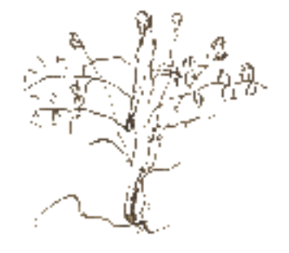

MS is on two pieces of paper found with a specimen of Senna magnifolia (MEL 1061235), the date of collection of which is unrecorded. The first sheet is annotated by M: 'Cassia magnifolis F.v.M.' The second sheet commences 'I made this plant out'. A smaller third sheet carries the sketch of the plant: 74-00-00e_image01.jpg Bailey was communicating with M by 1874, the year in which Bailey was appointed to prepare a Queensland Herbarium (see report of the Queensland Acclimatisation Society, Telegraph (Brisbane), 6 March 1875, p. 5); the first fully dated letter found is F. Bailey to M, 1 January 1875, and it mentions assistance from M before that. (Bailey's earliest dated specimen at MEL, however, filed as Eucalyptus pruinosa (MEL 1614037), is dated to 3 September 1869.) The item is therefore dated to 1874 as the earliest likely date it would have been written.
The property of the Acclimatisation Society of Queensland in Brisbane.
At bottom right of sheet, separated from the remainder of the text by a line, Bailey has written ‘top of leaf’.

